**Create a React App named “bloggerapp” in with 3 components.**

1. **Book Details**
2. **Blog Details**
3. **Course Details**

**Implement this with as many ways possible of Conditional Rendering.**

**Steps:**

1. **Set up the React App**

npx create-react-app bloggerapp

cd bloggerapp

npm start

1. **Create Component Files**

Inside src/, create the following files:

* BookDetails.js
* BlogDetails.js
* CourseDetails.js

1. **BookDetails Component**

// BookDetails.js

import React from 'react';

function BookDetails({ books }) {

  if (!books || books.length === 0) {

    return <div>No books available.</div>;

  }

  return (

    <div>

      <h2>Book Details</h2>

      <ul>

        {books.map((book) => (

          <li key={book.id}>

            <strong>{book.bname}</strong> - {book.price}

          </li>

        ))}

      </ul>

    </div>

  );

}

export default BookDetails;

1. **BlogDetails Component**

**//**BlogDetails.js

import React from 'react';

function BlogDetails({ blogs }) {

  if (!blogs || blogs.length === 0) {

    return <div>No blogs available.</div>;

  }

  return (

    <div>

      <h2>Blog Details</h2>

      <ul>

        {blogs.map((blog) => (

          <li key={blog.id}>

            <strong>{blog.title}</strong> by {blog.author}

            <div>{blog.content}</div>

          </li>

        ))}

      </ul>

    </div>

  );

}

export default BlogDetails;

1. **CourseDetails Component**

**//**CourseDetails.js

import React from 'react';

function CourseDetails({ courses }) {

  if (!courses || courses.length === 0) {

    return <div>No courses available.</div>;

  }

  return (

    <div>

      <h2>Course Details</h2>

      <ul>

        {courses.map((course) => (

          <li key={course.id}>

            <strong>{course.name}</strong> - {course.date}

          </li>

        ))}

      </ul>

    </div>

  );

}

export default CourseDetails;

1. **Main App Component with Conditional Rendering**

//App.js

import React, { useState } from 'react';

import BookDetails from './BookDetails';

import BlogDetails from './BlogDetails';

import CourseDetails from './CourseDetails';

import './App.css';

function App() {

  // Sample data

  const books = [

    { id: 101, bname: 'Master React', price: 670 },

    { id: 102, bname: 'Deep Dive into Angular 11', price: 800 },

    { id: 103, bname: 'Mongo Essentials', price: 450 },

  ];

  const blogs = [

    { id: 1, title: 'React Learning', author: 'Stephen Biz', content: 'Welcome to learning React!' },

    { id: 2, title: 'Installation', author: 'Schewzdenier', content: 'You can install React from npm.' },

  ];

  const courses = [

    { id: 1, name: 'Angular', date: '4/5/2021' },

    { id: 2, name: 'React', date: '6/3/2021' },

  ];

  // State for conditional rendering

  const [showBooks, setShowBooks] = useState(true);

  const [showBlogs, setShowBlogs] = useState(true);

  const [showCourses, setShowCourses] = useState(true);

  let courseSection = null;

  if (showCourses) {

    courseSection = <div className="section"><h1>Course Details</h1><CourseDetails courses={courses} /></div>;

  }

  return (

    <div className="App">

      <h1>Blogger App</h1>

      <button onClick={() => setShowBooks((v) => !v)}>Toggle Book Details</button>

      <button onClick={() => setShowBlogs((v) => !v)}>Toggle Blog Details</button>

      <button onClick={() => setShowCourses((v) => !v)}>Toggle Course Details</button>

      <div className="main-container">

        {/* Book Details Section */}

        <div className="section">

          <h1>Book Details</h1>

          {showBooks && <BookDetails books={books} />}

        </div>

        {/* Vertical Divider */}

        <div className="vl"></div>

        {/* Blog Details Section */}

        <div className="section">

          <h1>Blog Details</h1>

          {showBlogs ? <BlogDetails blogs={blogs} /> : <div>Blog Details Hidden</div>}

        </div>

        {/* Vertical Divider */}

        <div className="vl"></div>

        {/* Course Details Section */}

        {courseSection}

      </div>

    </div>

  );

}

export default App;

1. **Styling**

//App.css

body {

  margin: 0;

  padding: 0;

  font-family: Arial, sans-serif;

}

.main-container {

  display: flex;

  justify-content: space-around;

  align-items: flex-start;

  margin-top: 60px;

}

.section {

  flex: 1;

  padding: 0 30px;

  text-align: left;

}

.section h1, .section h2 {

  font-weight: bold;

}

.vl {

  border-left: 5px solid green;

  height: 350px;

  margin: 0 20px;

}

/* Remove default App-header and App centering for main content */

.App-header {

  background: none;

  min-height: unset;

  display: none;

}

.App {

  text-align: left;

}

1. **Run the App**

npm start

**Output:**

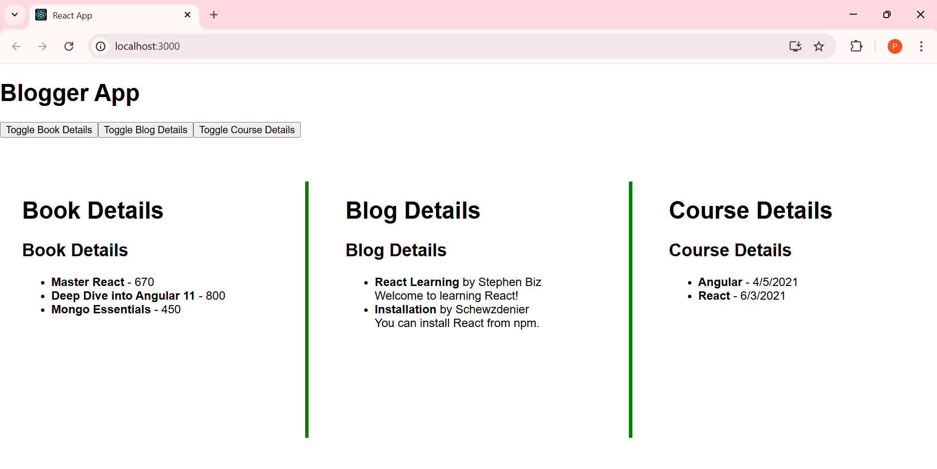

**Toggle Book Details**

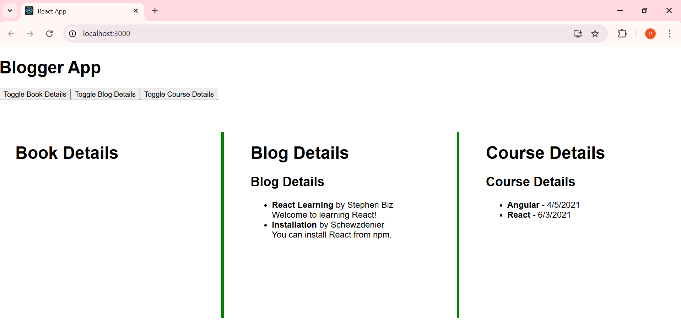

**Toggle Blog Details**

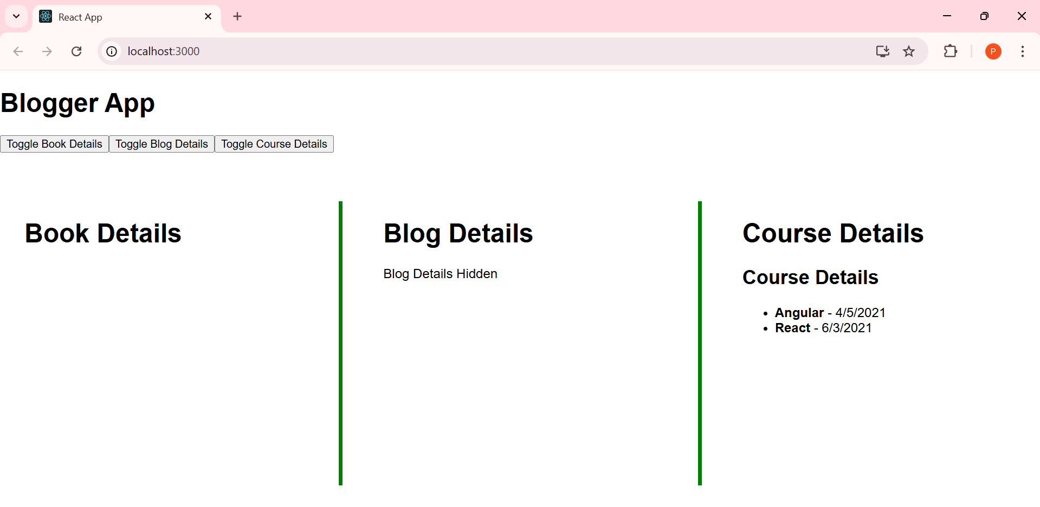

**Toggle Course Details**

